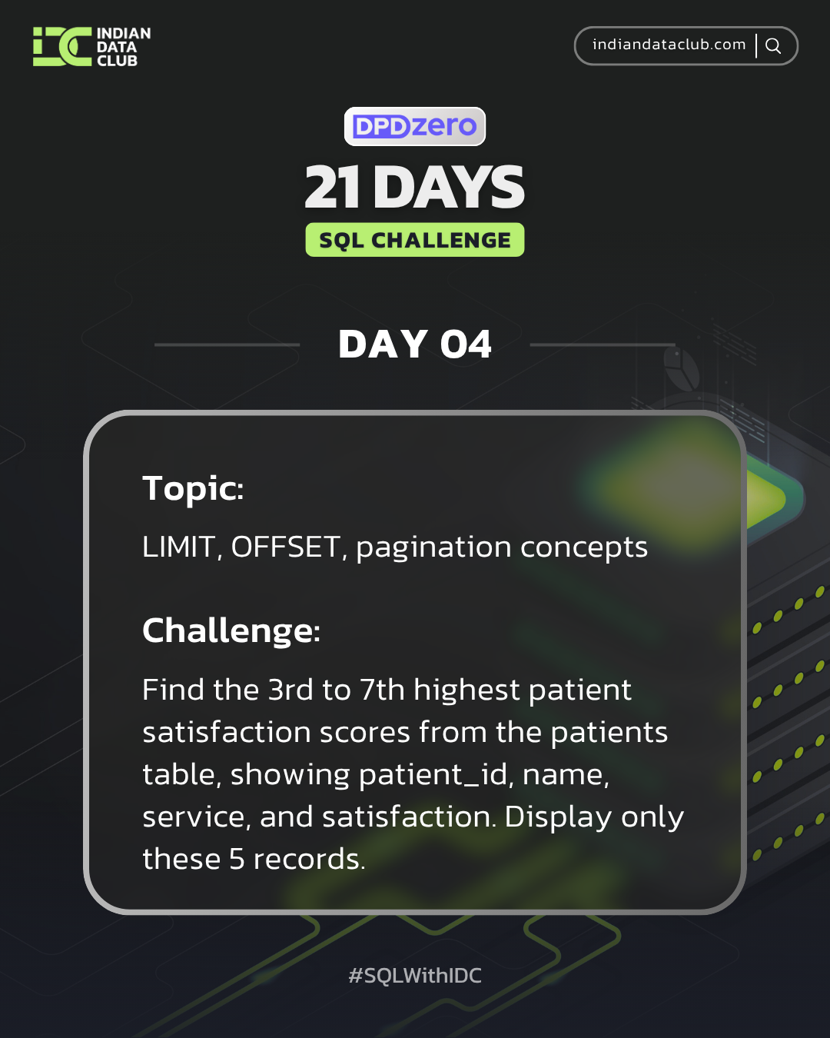
Day-4 SQL Challenge
Day-4 Challenge:
Find the 3rd to 7th highest patient satisfaction scores from the patients table, showing patient_id, name, service, and satisfaction. Display only these 5 records.
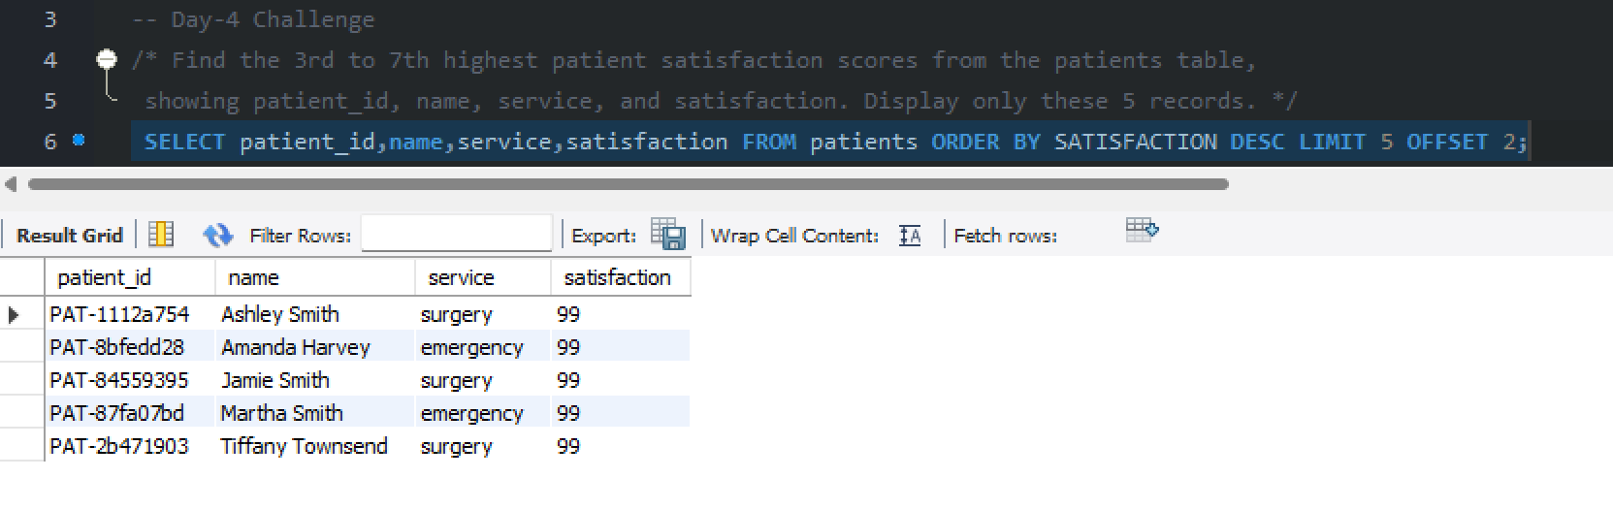

Practice Questions:
1.Display the first 5 patients from the patients table.
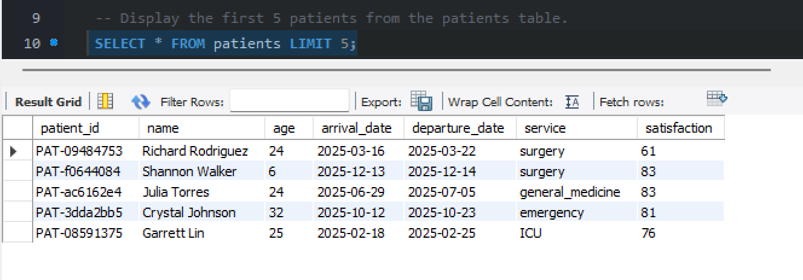

2. Show patients 11-20 using OFFSET.
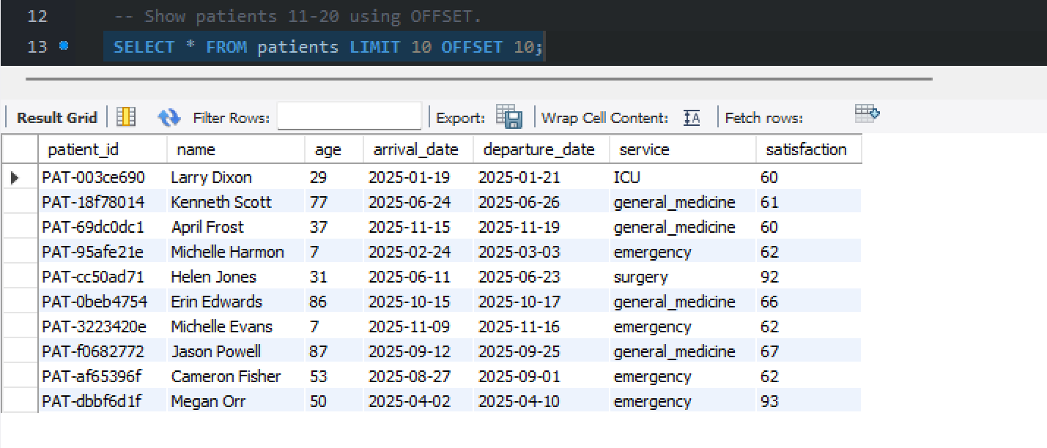

3. Get the 10 most recent patient admissions based on arrival_date.
